**LAB 2**

**1.Write a program that accepts numbers continuously as long as the number is positive and prints the sum of the given numbers.**

#include<iostream>

using namespace std;

int main()

{

cout<<"Enter numbers: ";

int n,sum=0;

while(n>0)

{

cin>>n;

if(n<0)

break;

sum=sum+n;

}

cout<<"Sum ="<<sum;

return 0;

}

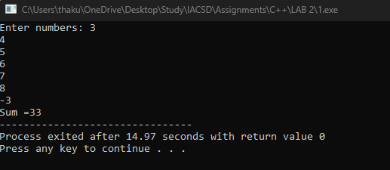

**2. Write a program to accept two integers x and n and compute x raised to n.**

#include<iostream>

using namespace std;

int main()

{

int a=1,base,power;

cout<<"Enter base and power:";

cin>>base>>power;

for(int i=1;i<=power;i++)

{

a=a*base;

}

cout<<base<<" raised to "<<power<<" is "<<a;

return 0;

}

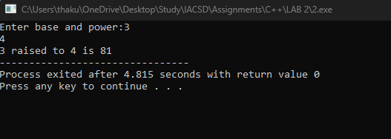

**3. Write a program to accept a character, an integer n and display the next n characters.**

#include<iostream>

using namespace std;

int main()

{

int n;

char ch,c;

cout<<"Enter a character:";

cin>>c;

cout<<"Enter the value upto which you want to print next characters:";

cin>>n;

for(int i=1;i<=n;i++)

{

ch=c+i;

cout<<ch<<" ";

}

//int a;

//a='A';

//cout<<a;

}

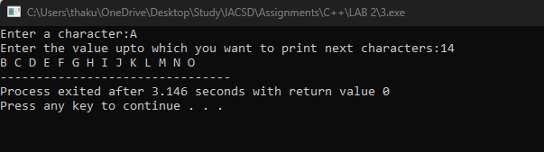

**4. Write a program to calculate factorial of a number.**

#include<iostream>

using namespace std;

int main()

{

int n,fact=1;

cout<<"Enter the number for factorial: "<<endl;

cin>>n;

for(int i=1;i<=n;i++)

{

fact=fact*i;

}

cout<<"Fact = "<<fact;

return 0;

}

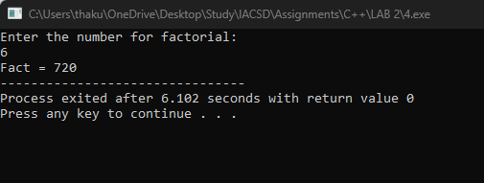

**5. Write a program to calculate factors of a given number.**

#include<iostream>

using namespace std;

int main()

{

int n,count=0;

cout<<"Enter a number - ";

cin>>n;

cout<<"Factors are - ";

for(int i=1;i<=n;i++)

{

if(n%i==0)

{

cout<<i<<" , ";

count++;

}

}

cout<<"\nNumber of factors - "<<count;

return 0;

}

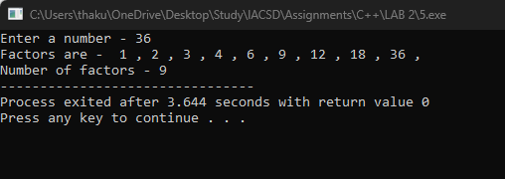

**6. Accept two numbers and calculate GCD of them.**

#include<iostream>

using namespace std;

int main()

{

int n1,n2,h;

cout<<"Enter two numbers :";

cin>>n1>>n2;

for(int i=1;i<=n1&&i<=n2;i++)

{

if(n1%i==0&&n2%i==0)

{

h=i;

}

}

cout<<"\nThe GCD of "<<n1<<" and "<<n2<<" is "<<h;

return 0;

}

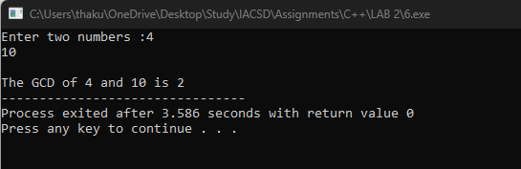

**7. Write a menu driven program to do following operations :**

**a) Compute area of circle**

**b) Compute area of rectangle**

**c) Compute area of triangle**

**d) Exit**

**Display menu, ask choice to the user, depending on choice accept the parameters and perform the**

**operation. Continue this process until user selects exit option.**

#include<iostream>

using namespace std;

int main()

{

int ch,rb,rh,tb,th;

float r;

cout<<"1. Circle 2.Rectangle 3.Triangle 4.Exit ";

do

{

cout<<"\nEnter your choice-";

cin>>ch;

switch(ch)

{

case 1:

cout<<"\nEnter the radius of circle- ";

cin>>r;

cout<<"\nArea = "<<(22/7)*r*r;

break;

case 2:

cout<<"\nEnter the base and height of ractangle-";

cin>>rb>>rh;

cout<<"Area = "<<rb*rh;

break;

case 3:

cout<<"\n Enter the base and height of triangle-";

cin>>tb>>th;

cout<<"Area = "<<tb*th;

break;

default:

cout<<"Enter valid choice!!! ";

}

}while(ch!=4);

return 0;

}

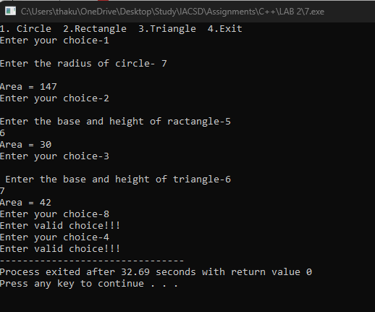

**8. Write a program to print all prime numbers between 1 to n**

#include<iostream>

using namespace std;

void find(int a)

{ bool f=false;

for(int i=1;i<=a;i++)

{

if((i!=1&&i!=a)&&a%i==0)

{

f=true;

break;

}

}

if(!f)

cout<<a<<" ";

}

int main()

{

int n;

cout<<"Enter a number till you want to print prime numbers";

cin>>n;

for(int i=1;i<=n;i++)

{

find(i);

}

}

